**Progress for Every Child in the Sustainable Development Goal (SDG) Era  
By**

**Anish Nitin Somaiah**

WEEK 6: FINAL Assignment

ALY 6070 21048 Communication and Visualization for Data Analytics

**PROF. YONI DVORKIS**

17 February 2019



**Introduction:**

The under-five mortality rate is **the probability (expressed as a rate per 1,000 live births) of a child born in a specified year dying before reaching the age of five**. Due to various significant reasons like economy, geography, diversity, healthy environments, medical capital & infrastructure and so on, there is a huge difference is the U5MR across various parts of the globe. This phenomenon is not only restricted to underdeveloped nations but is also applicable and still visibly observed in high economy and ecology countries as well. Here we analyze the under five mortality rates of three different countries under various scenarios to understand the bigger picture of this world crisis. We use the UNICEF data sets obtained from the below weblink to perform the analysis which is as follows:

<https://data.unicef.org/topic/child-survival/under-five-mortality/>

**Countries under consideration and reason.**

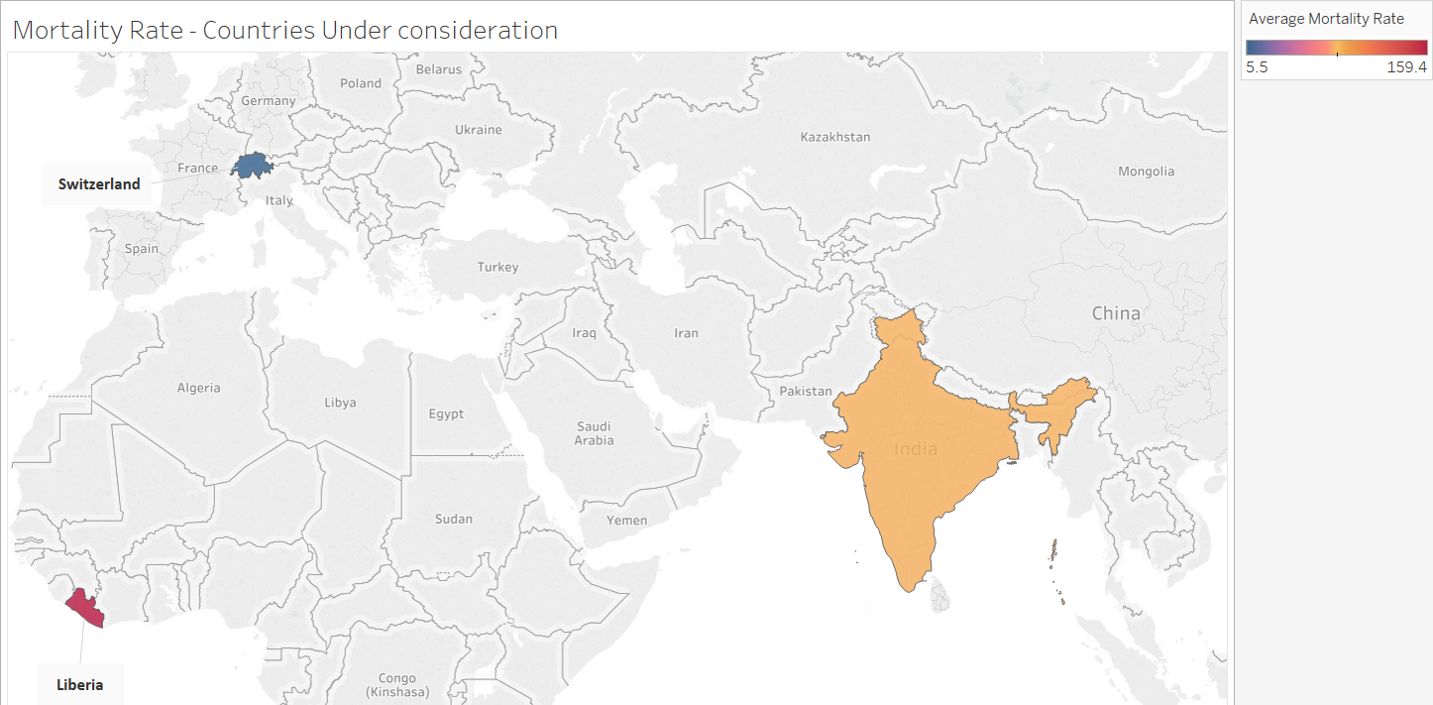

**For the above analysis the countries under consideration are:**

1. **India : As India is a geographically wide spread country exhibiting multiple diversity and multiple ecological and economical aspects across the entire country. Also, the Mortality rate exhibited in this country has not been very low or high.**
2. **Switzerland : As Switzerland having a string geographical limitations, have exhibited better mortality rates due to its best economy and also due to the medical innovations and also host of the headquarters of World Health Organization.**
3. **Liberia : As Liberia is one of the most economically poor and one among the unhealthy countries in the sub Saharan African continent that exhibits very low mortality rates.**

**INDIA:**

From our above dataset we are to compare the median average mortality rate of **INDIA to the average mortality rate median to South Asia Region and Southern Asia SDG** at mid-2017. We also analyze the top 3 contributors of the death of under 5 age children during 2016. By using tableau and considering the required data we have a dashboard as follows:

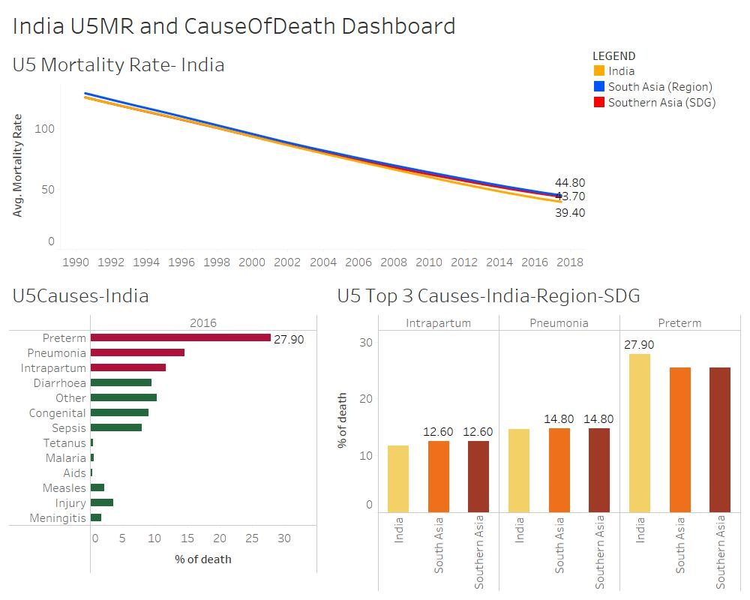

From the Above Dashboard we obtain the following key inferences:

* The average mortality rate at the end of mid-2017 of India is **less than both regional and SDG** mortality rates. This indicates a positive note and it can be observed that as we progress from 1990 to 2018, the graph linearly decreases indicating the no.of deaths gradually decreasing.
* Close to 28% of the deaths under age 5 is caused due to preterm and they are followed up by Pneumonia with 14.6% and Intrapartum with 11.7%. This inference is obtained from the second plot which indicates that the **highest cause of infant mortality in India is Preterm births** which is a scenario of baby being born before the 37-week period.
* When considering a relationship between the top 3 cause of death of India with its region South Asia we observe that **Pneumonia and Intrapartum are below the regional estimate** but there is a very significant difference when it comes to Preterm deaths. It is higher in India compared to the South Asian region, Hence India should be working on this particular cause to meet its Sustainable Development Goals by 2030.

**SWITZERLAND:**

From our above dataset we are to compare the median average mortality rate of **SWITZERLAND to the average mortality rate median to Western Europe Region and Europe SDG** at mid-2017. We also analyze the top 3 contributors of the death of under 5 age children during 2016. By using tableau and considering the required data we have a dashboard as follows:

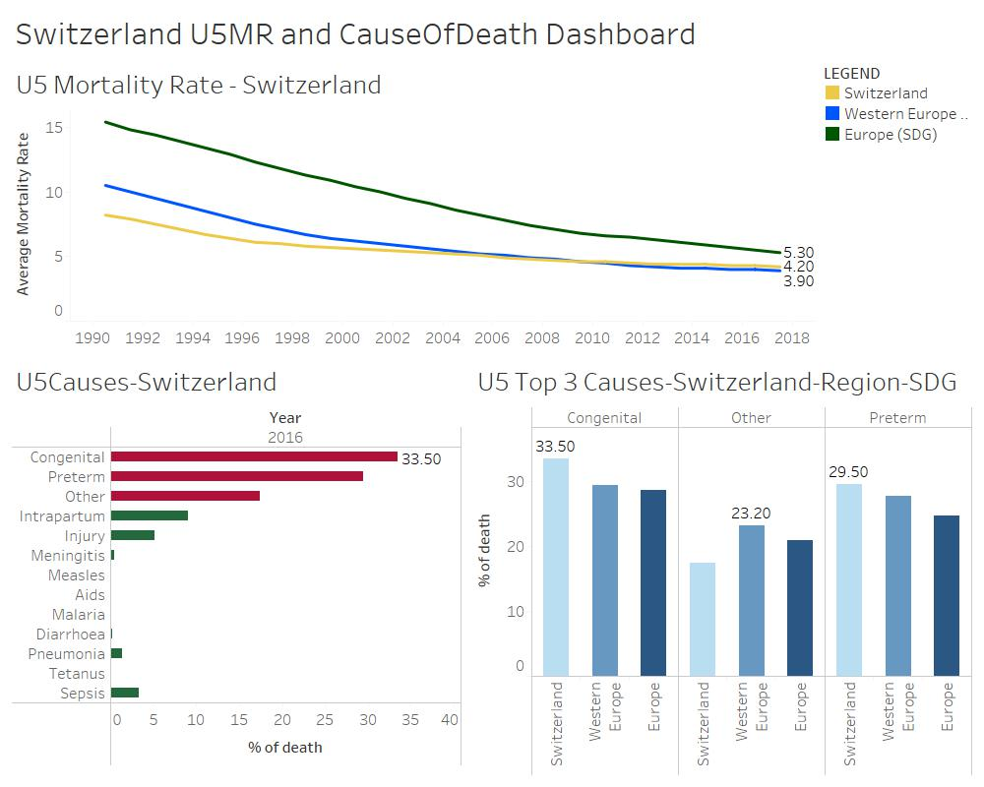

From the Above Dashboard we obtain the following key inferences:

* The average mortality rate at the end of mid-2017 of Switzerland is **greater than regional but less than SDG mortality rates**. This indicates that the country has met the SDG goals and it can be observed that as we progress from 1990 to 2018, the mortality rate of this country has been less than 10% which indicates the least no.of deaths of newborn children in the country and in Europe as a whole.
* Close to 33.5% of the deaths under age 5 is caused due to Congenital and they are followed up by Preterm with 29.5% and Other causes with 17.4%. This inference is obtained from the second plot which indicates that the **highest cause of infant mortality in Switzerland is Congenital births** which is a scenario of baby being born with birth problems.
* When considering a relationship between the top 3 cause of death of Switzerland with its region Western Europe we observe that **both Congenital and Preterm are above the regional estimate**. Hence Switzerland should be working on these particular causes to meet its Sustainable Development Goals by 2030.

**LIBERIA:**

From our above dataset we are to compare the median average mortality rate of **LIBERIA to the average mortality rate median to Sub Saharan Region and Sub Saharan SDG** at mid-2017. We also analyze the top 3 contributors of the death of under 5 age children during 2016. By using tableau and considering the required data we have a dashboard as follows:

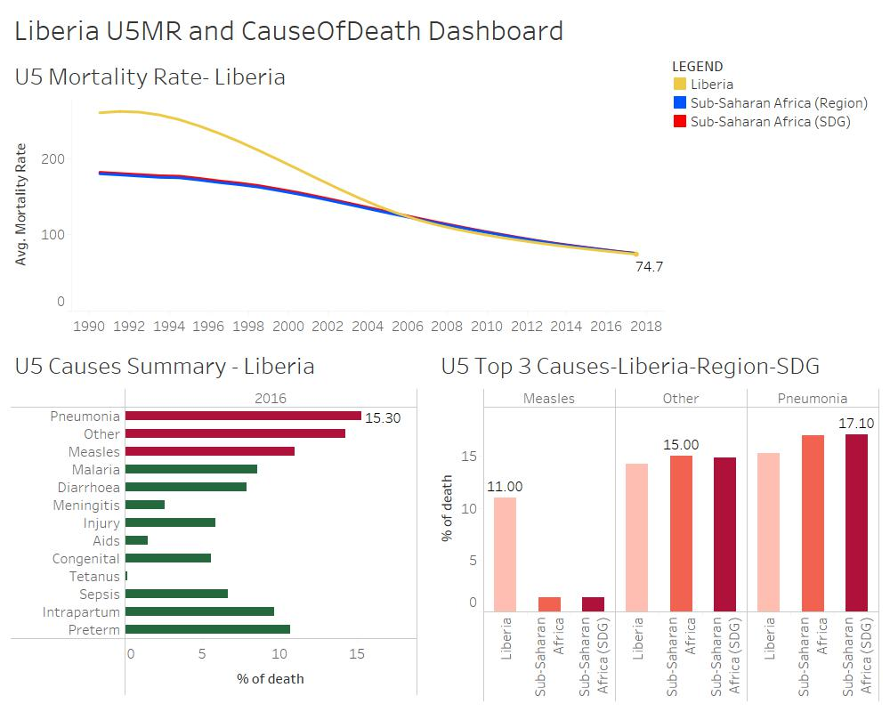

From the Above Dashboard we obtain the following key inferences:

* The average mortality rate at the end of mid-2017 of Liberia **is equal to both regional SDG mortality rates**. This indicates that the country has met the SDG goals and it can be observed that as we progress from 1990 to 2018, the mortality rate of this country has Significantly reduced from 265 to 74.7. But still close to 75% mortality rate is a very low mortality rate and a very serious issue to the countries infants.
* Close to 15.3% of the deaths under age 5 is caused due to Pneumonia and they are followed up by Other causes with 14.3% and Measles with 11%. This inference is obtained from the second plot which indicates that the **highest cause of infant mortality in Liberia is Pneumonia** which is a scenario of baby being born with air sacs in lungs. This is due to the difficult ecological condition of the country and due to very few preventive measures adopted due to the low economy of the country.
* When considering a relationship between the top 3 cause of death of Liberia with its region we observe that **only Measles is above the regional estimate**. Hence Liberia should be working on Measles to meet its Sustainable Development Goals by 2030.

**SUMMARY**

* **From the above findings we could summarize one key inference which is that all the countries considered did meet the Sustainable Development Goals at 2017.**
* **Since we were analyzing the Under 5 mortality rate , only the under 5 death causes were taken into consideration as using the data set with time period of child birth will add too much additional outlier information to the necessary analysis.**
* **In all cases there was a considerable amount of contribution of child death by the other causes. We were not given much insight about what the other causes are but a summarized dashboard for that as well is down below. But all the countries estimates were below the regional estimates which is the positive part of it.**
* **We have also visually analyzed the high mortality rate of a very low economy country hence a global solution of stabilizing economies should also be taken into action for all countries to not only meet SDG but to also significantly reduce the mortality rate to less than 10% in all countries.**

**The final summary dashboard is as follows:**

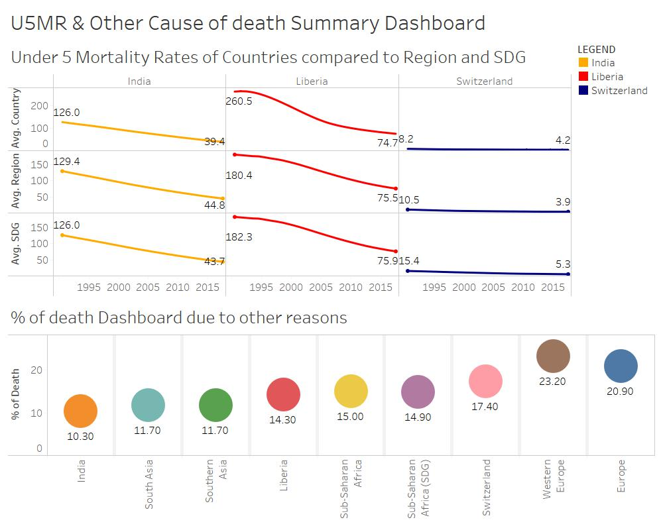

**References:**

**Regional groupings used in 2017 Report and Statistical Annex** retrieved from[**https://unstats.un.org/sdgs/indicators/regional-groups/**](https://unstats.un.org/sdgs/indicators/regional-groups/)

**Mortality rate, under-5 (per 1,000 live births)** retrieved from <https://data.worldbank.org/indicator/sh.dyn.mort?end=2017&start=2000>